PORTFOLIO
ASSIGNMENT OF CSE111
(ORIENTATION TO COMPUTING-1)
COMPUTER SCIENCE AND ENGINEERING
Submitted by:
Name: PARUL VERMA
Registration number: 12304573
Roll No.:04
Section: K23RK

Submitted to : DR. PUNEET THAPAR


LOVELY PROFESSIONAL UNIVERSITY

DECLARATION
I, PARUL VERMA , a student of Bachelor of Technology under CSE discipline at Lovely Professional University, Punjab, hereby declare that all the information furnished in this project report is based on my own work and is genuine

PARUL VERMA
Registrartion Number: 12304573

Platforms for profile creation | Link to student profile | Screenshot
Figma | Since internal profile doesn’t work, so I am attaching project link  Project1:  https://www.figma.com/file/LsX6JHrpwYpNdJsEeLzEjw/logo-1?node-id=0%3A1&t=wzsAkkvr0BAZZQLC-1 | 1
Quora | https://www.quora.com/profile/Nitika-Kalra-11 | 2
Stack overflow | https://stackoverflow.com/users/20933881/nitika | 3
Hacker Rank | https://www.hackerrank.com/nitikakalra2003 | 4
Hacker Earth | https://www.hackerearth.com/@nitika146 | 5-6
Geeks for Geeks | https://auth.geeksforgeeks.org/user/nitikakaggz3/practice | 7
LinkedIn | https://www.linkedin.com/home?originalSubdomain=in
Github | https://github.com/nitikakalra | 8
Git |  | 9
CV | https://docs.google.com/document/d/1Sz7plEAZMLnLDs8kGDTuEyq3WqEWgBTH/edit | 10
MOOCS done | 1.  https://www.cipherschools.com/videopage?courseid=618a5d12d64fed0023216620&video=19  2.  https://www.mygreatlearning.com/academy/learn-for-free/courses/python-fundamentals-for-beginners | 11
Technical MOOC Registration | Registration link here.

1.FIGMA
Profile:
Figma internal profile with project
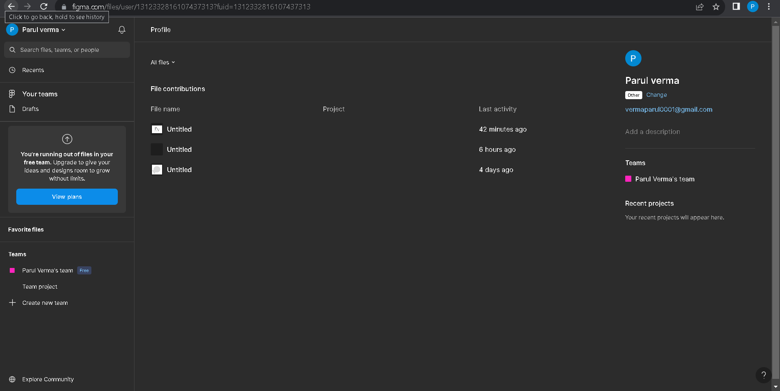
Accomplishment:
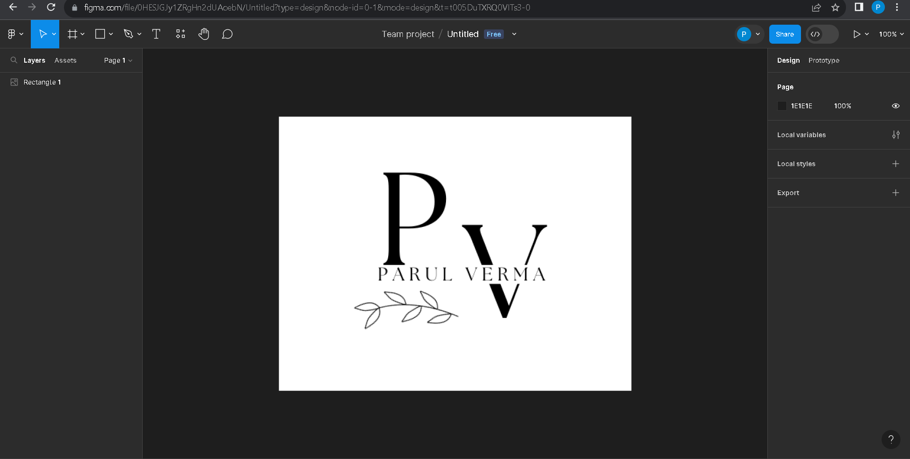

2.QUORA
PROFILE AND ACCOMPLISHMENT:
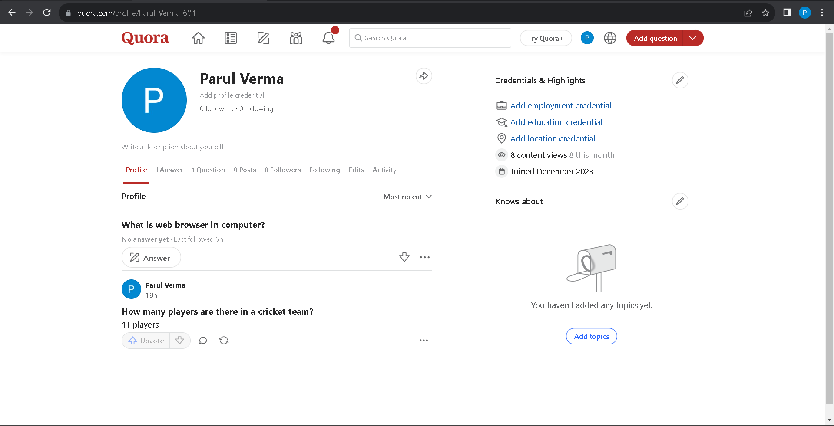

3.STACKOVERFLOW
PROFILE:
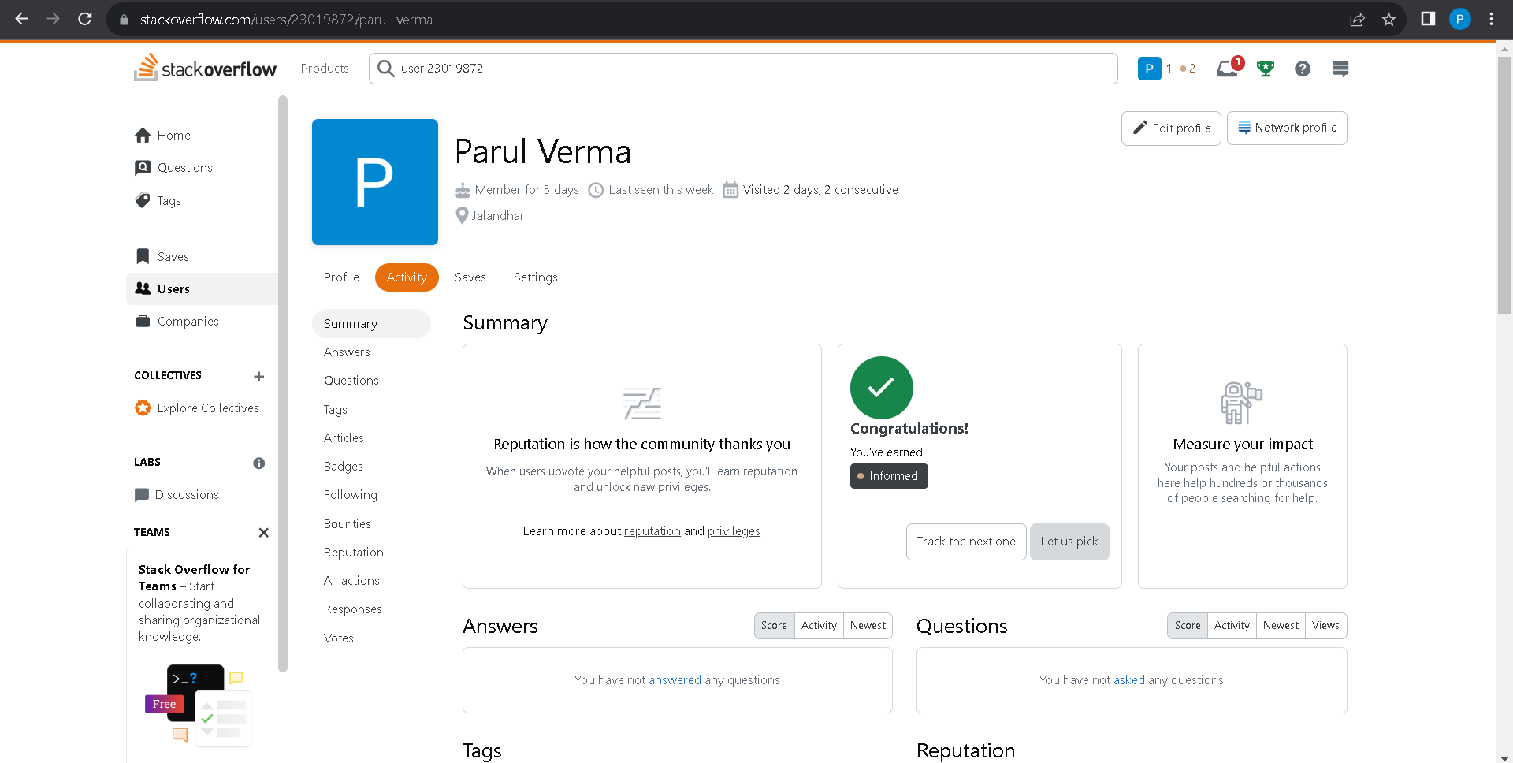
Accomplishment:
Raised a question and got a badge
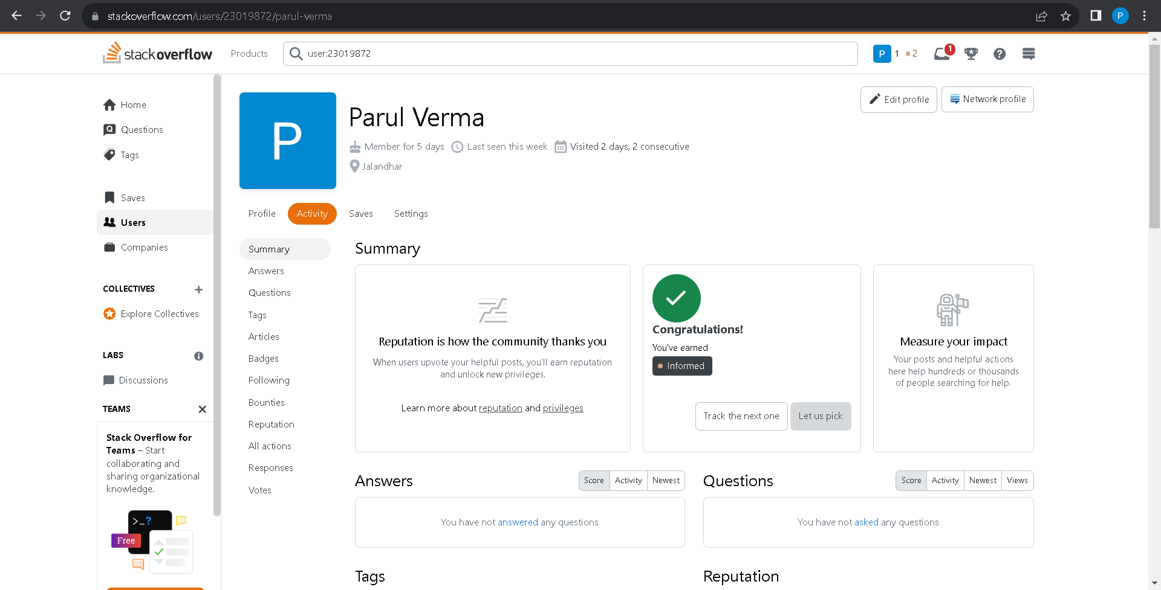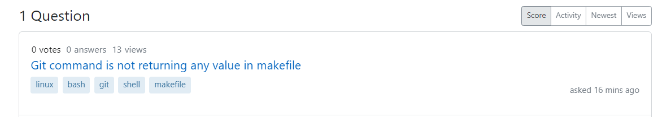
4.HACKER RANK
Profile:
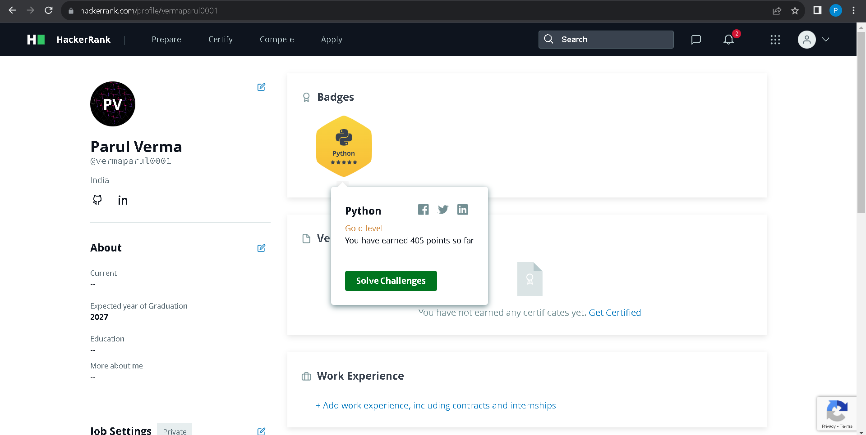
Accomplishment:
Achieved a five star badge in python by solving question.
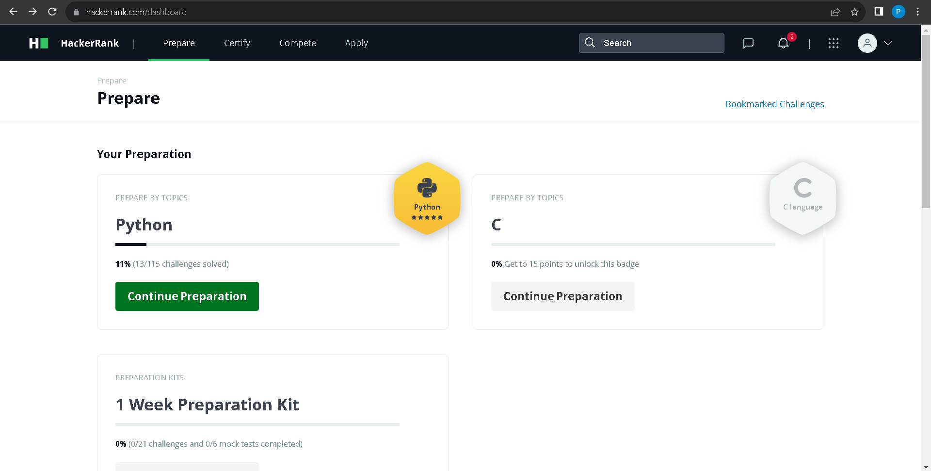

5.HACKER EARTH
Profile:
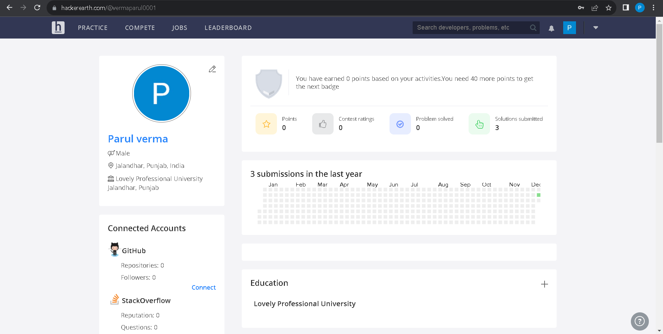

Accomplishment:
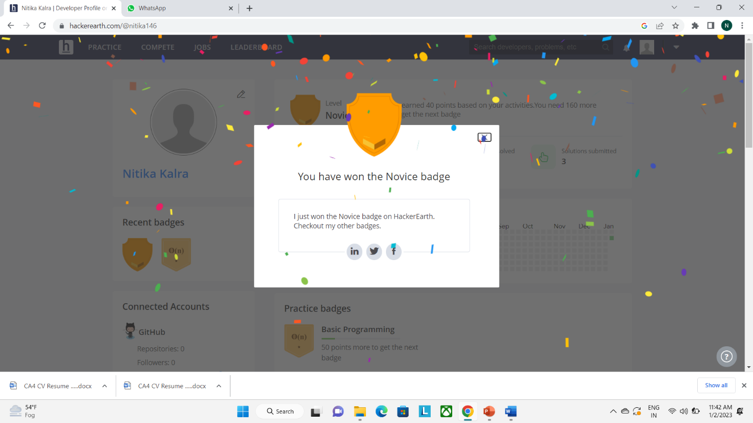
6. LINKED IN
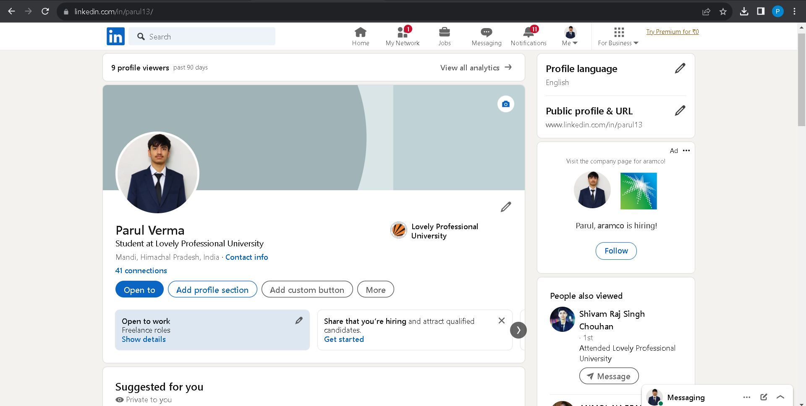

7.GEEKS FOR GEEKS
Profile:
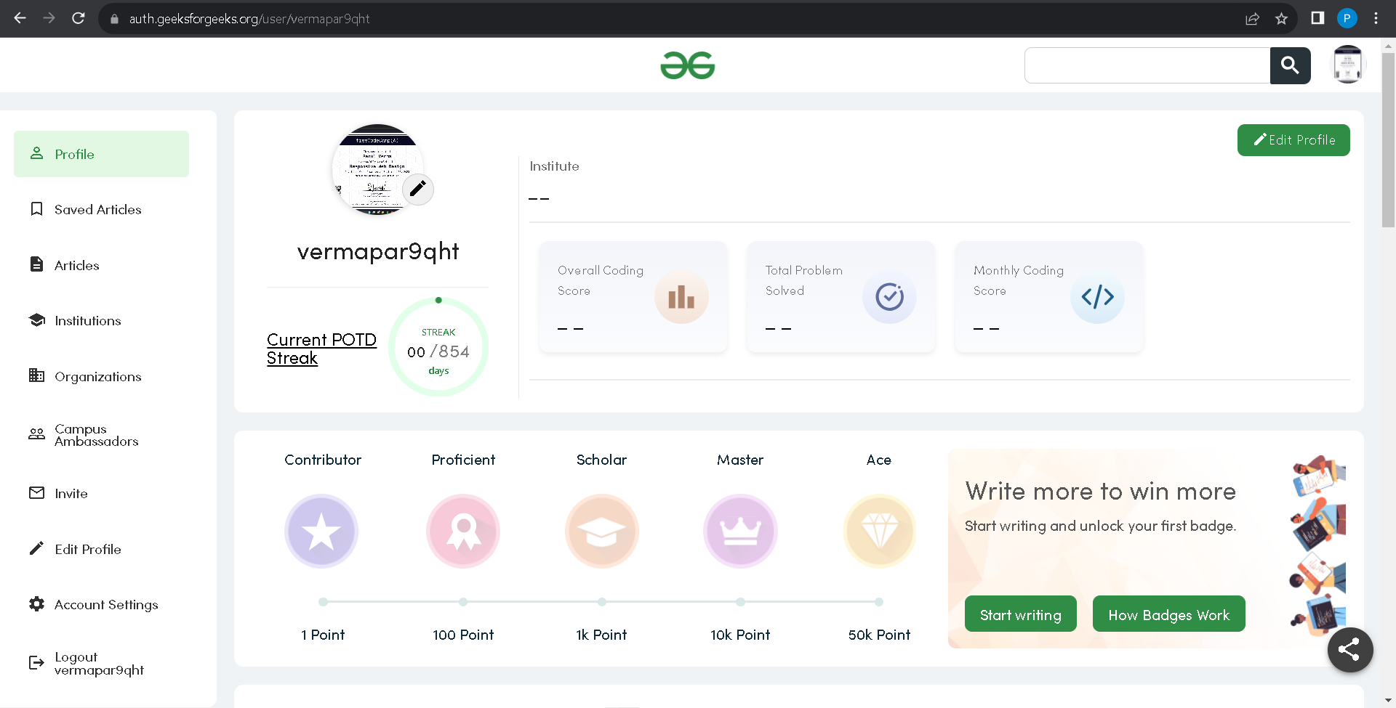

8
GITHUB
Profile:
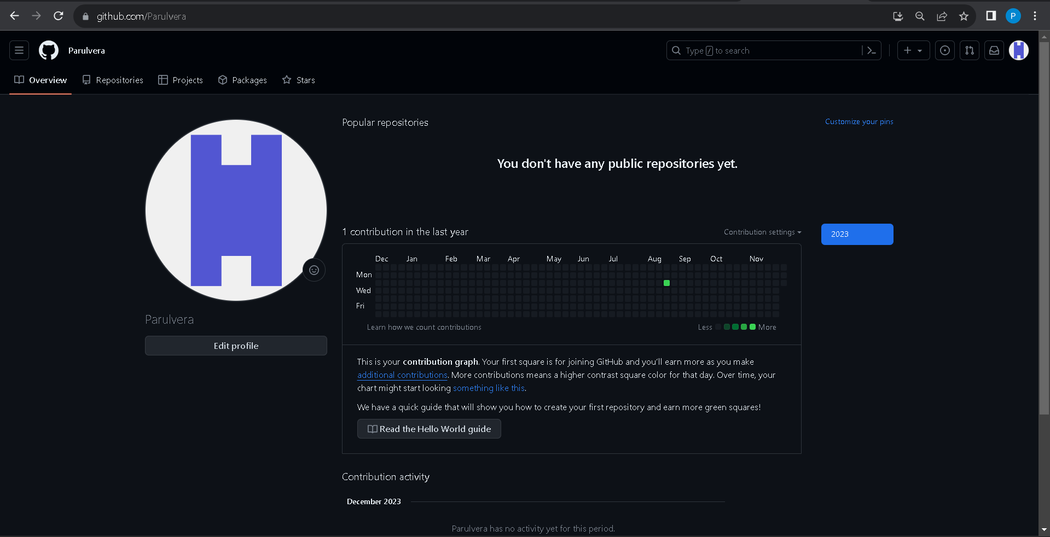
Accomplishment:
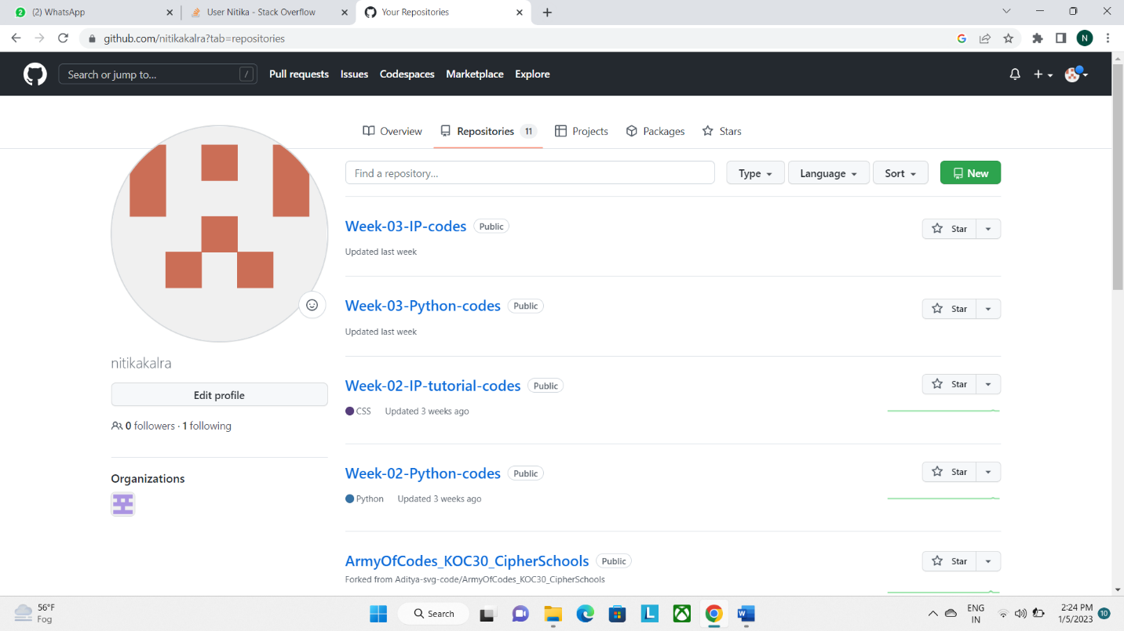
9.GIT
Accomplishment:
Created a repository and commited a file a in it .
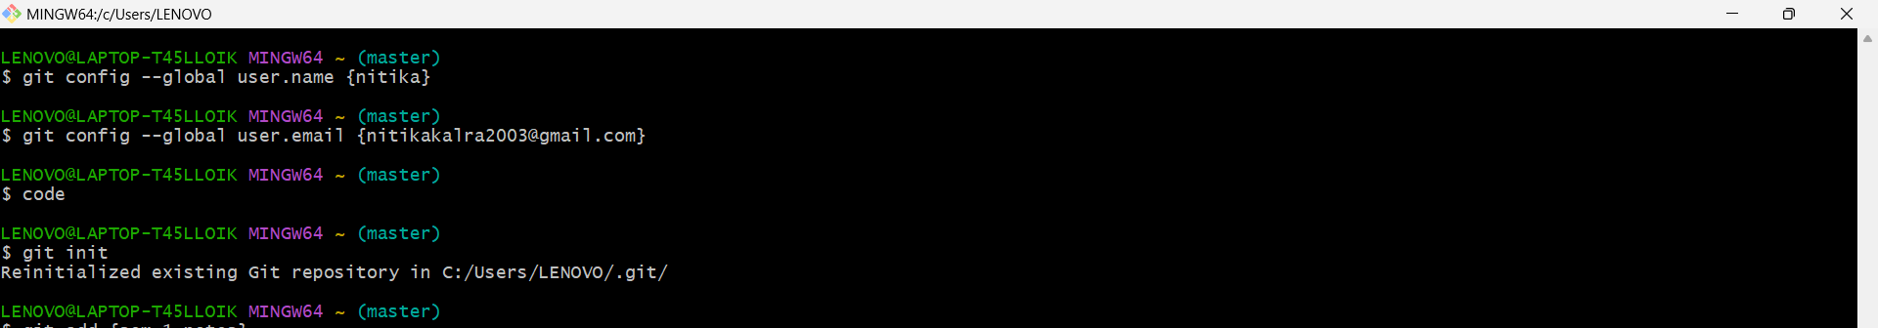

10.CV
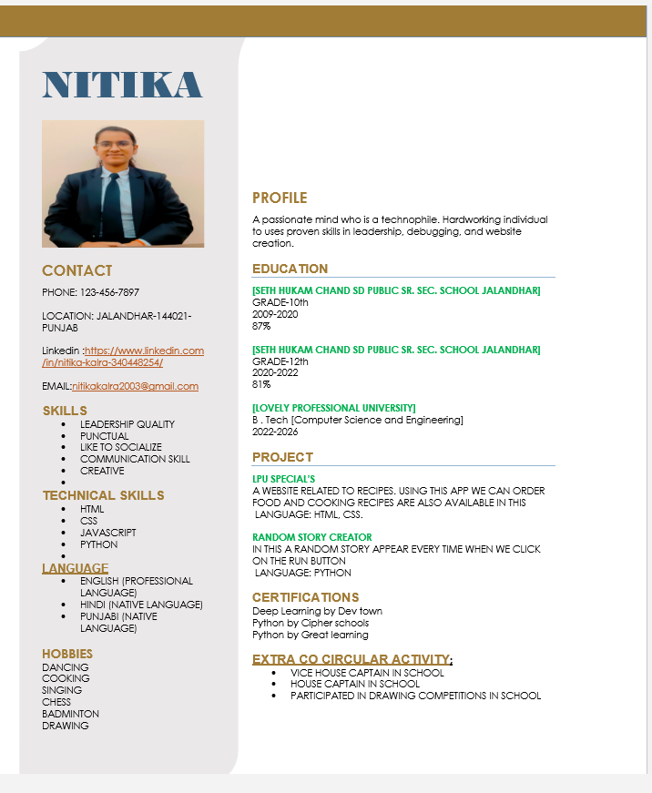

11.MOOCS completed
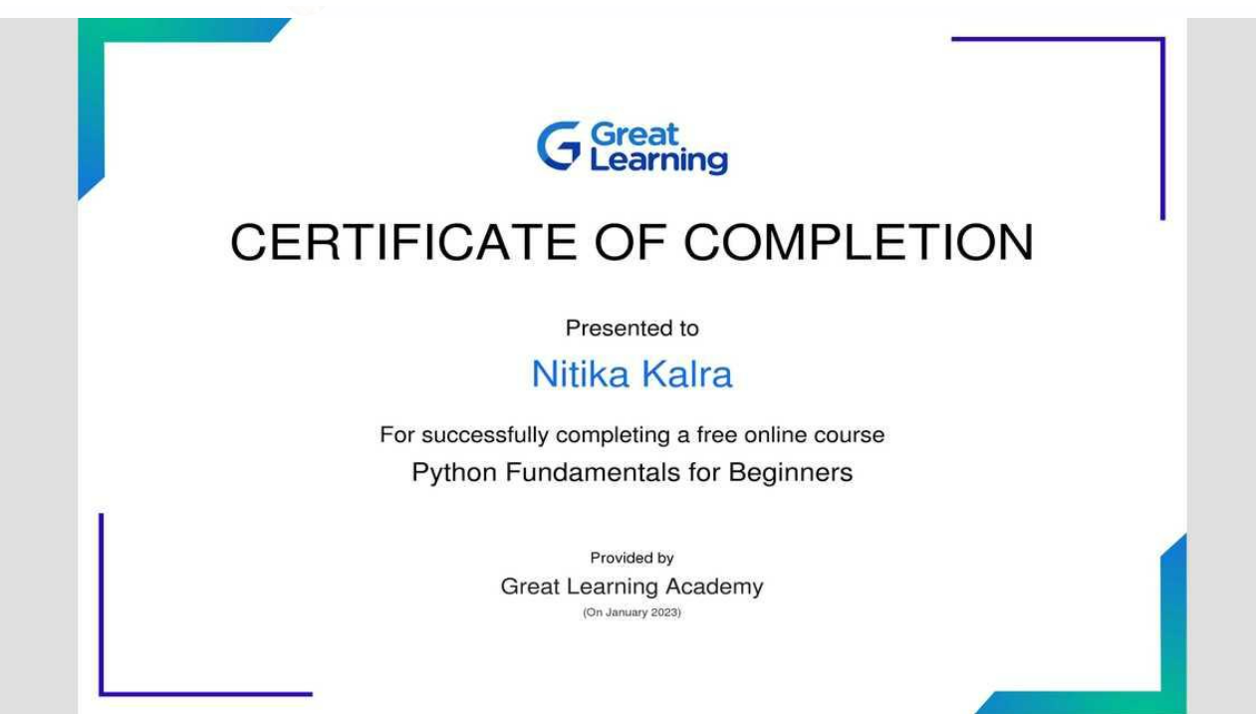

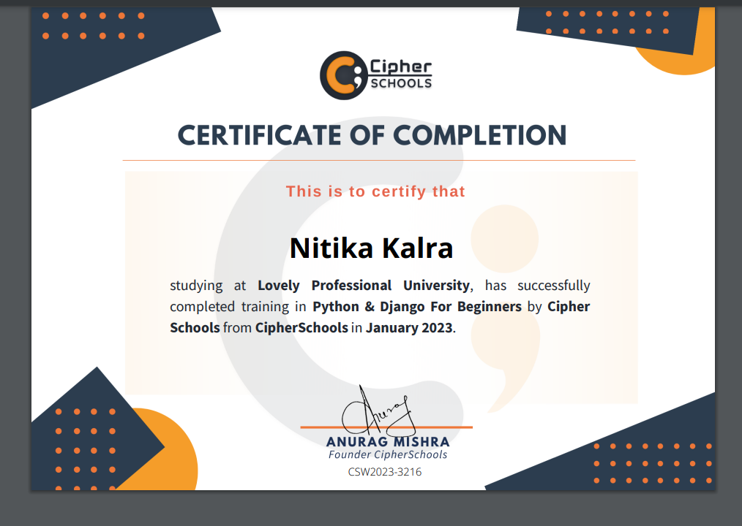

11.Technical MOOC registration Link

